**Round -1 Load testing**

Total Message on Source Historical topic =1,316,020

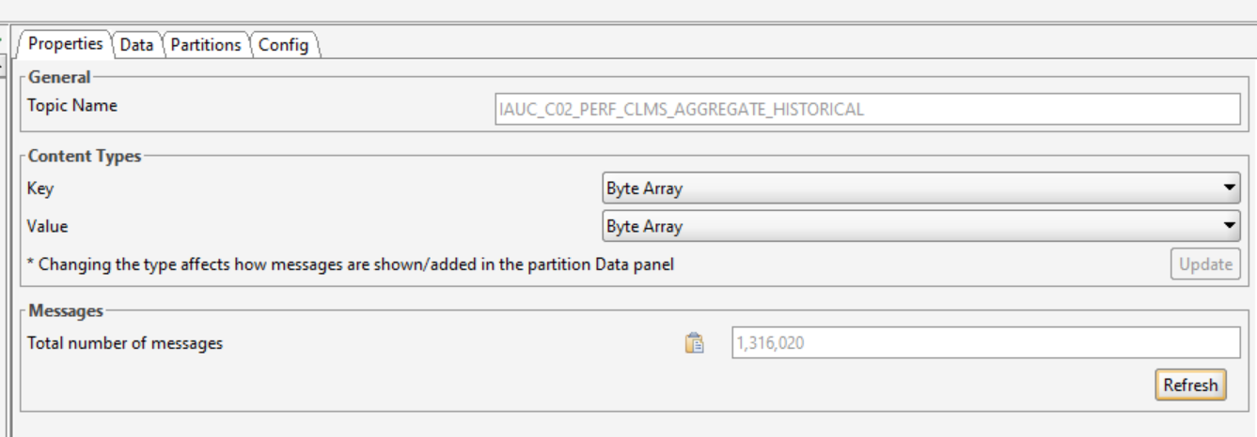

Production of messages Start Time- 10:04

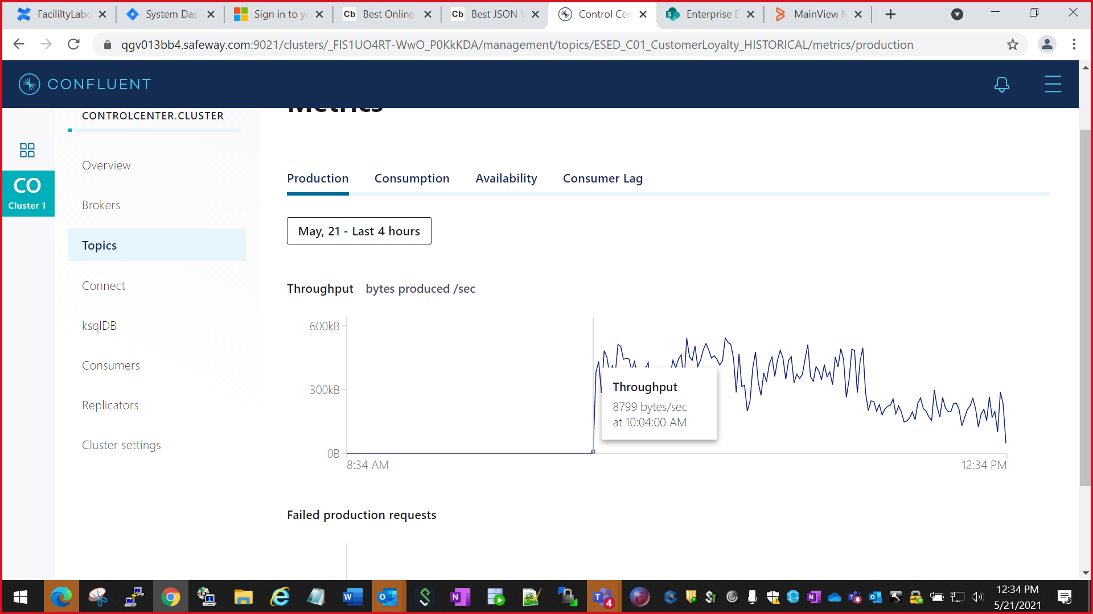

End time- 1:09 pm

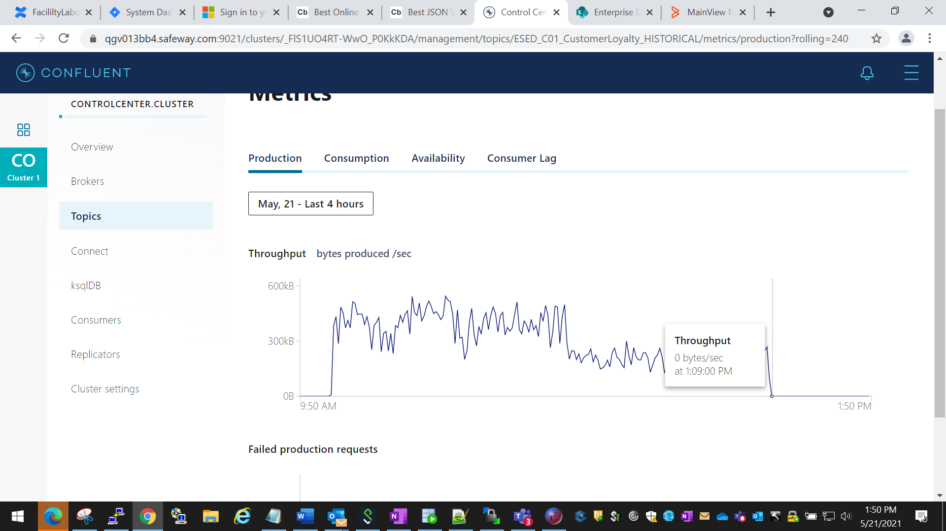

Total Message on the Historical topic- 1,316,029

ESED_C01_CustomerLoyalty_HISTORICAL

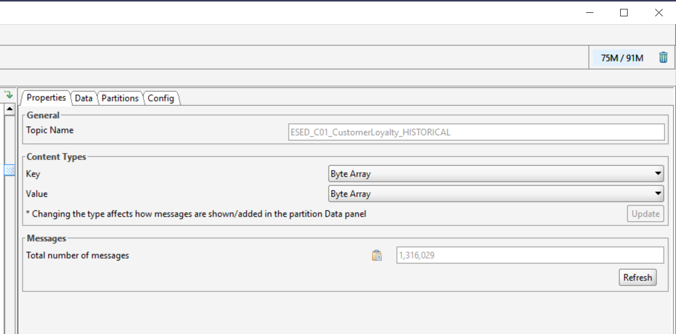

Total time taken in consumption of message = 3 Hours and 13 mins

**Round -2** Load testing after EDIS made the changes from 1 instance to 8 Instances on IIB Broker for

For ESED_C01_CustomerLoyalty_HISTORICAL

Production Start time- 2:49:00pm

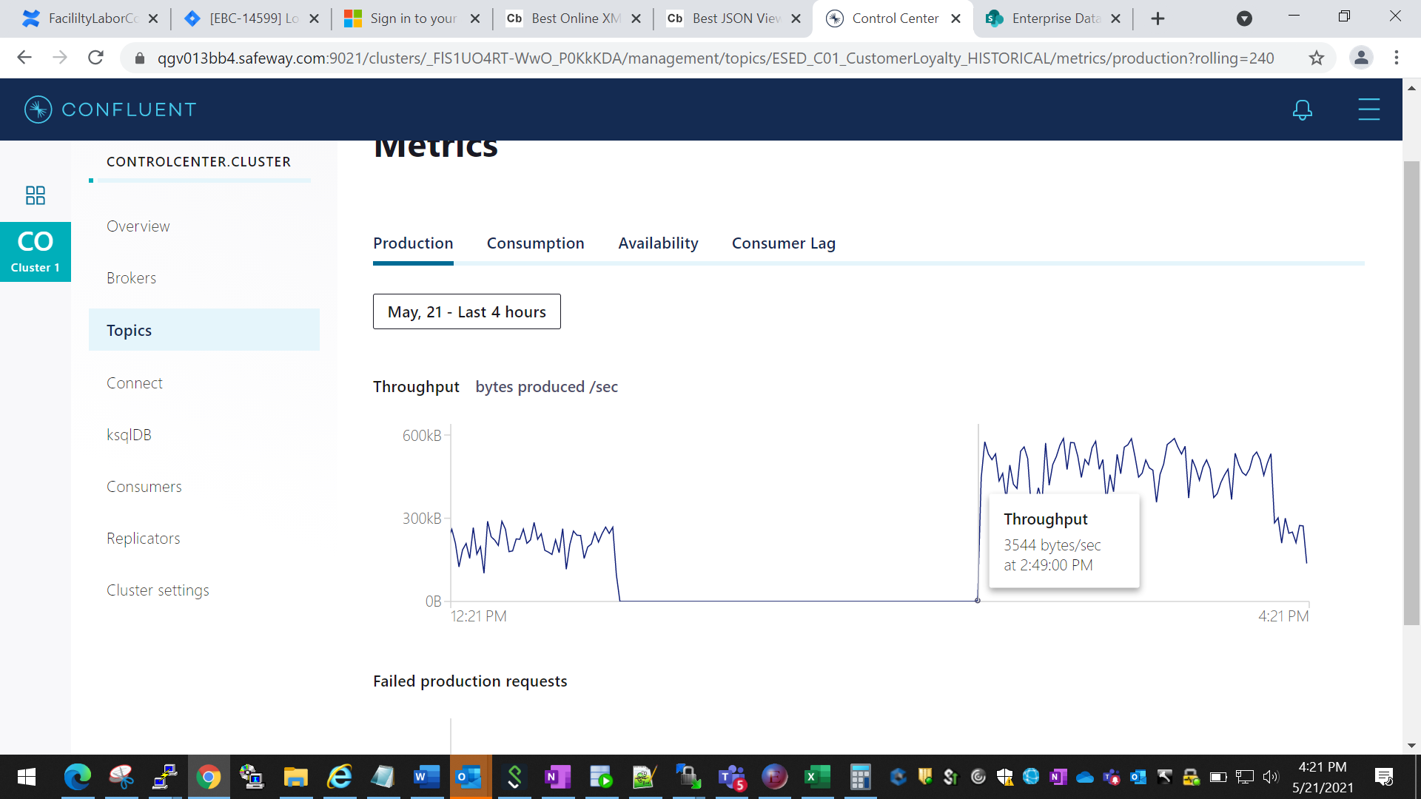

End Time- 5:20 Pm

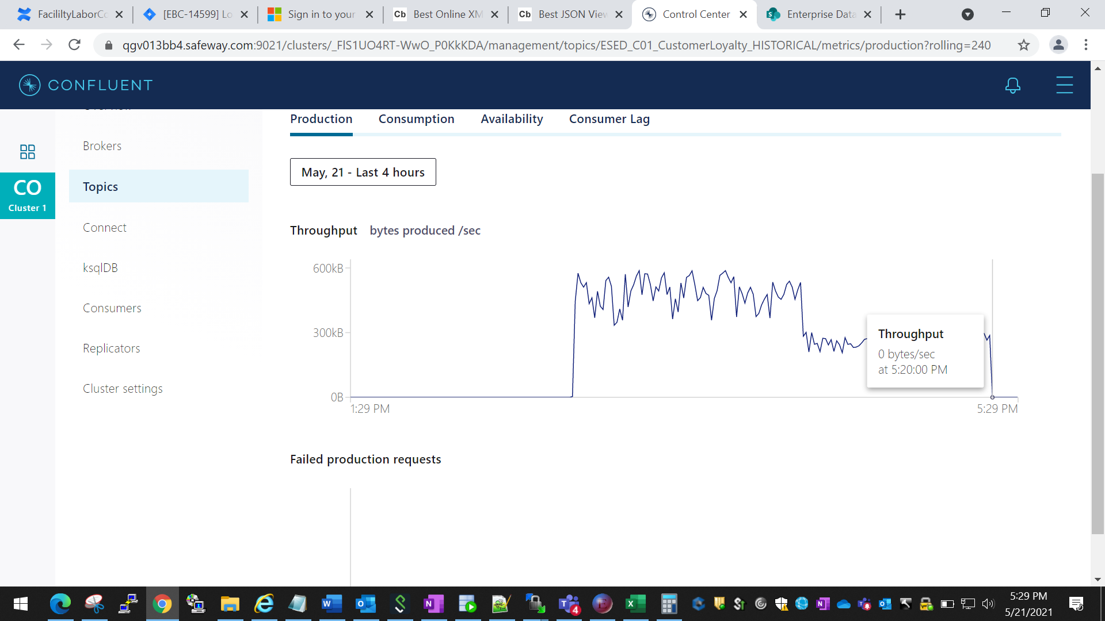

-

Total Message on Topic-

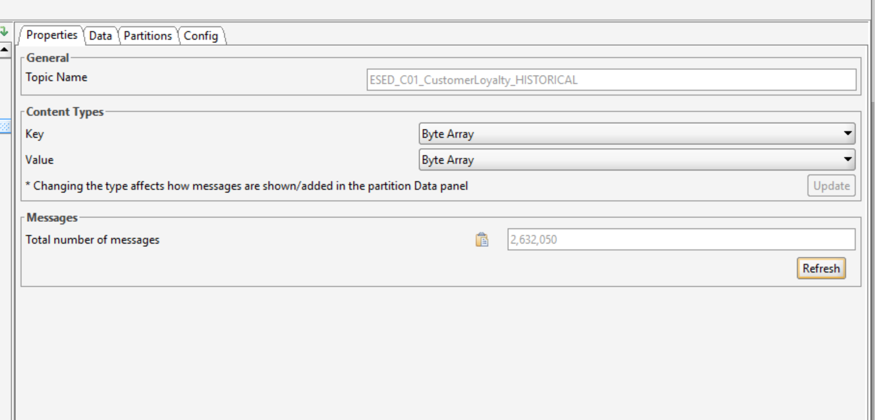

Old message count on topic, before started the consumption again-



Total No of new message consumed on topic- 1,316,021

**Total time taken in consumption of new message = 2 hours 31 mins**

**Round-3 Load Testing after changing the Partition from 3 to 12 on Kafka topic –**

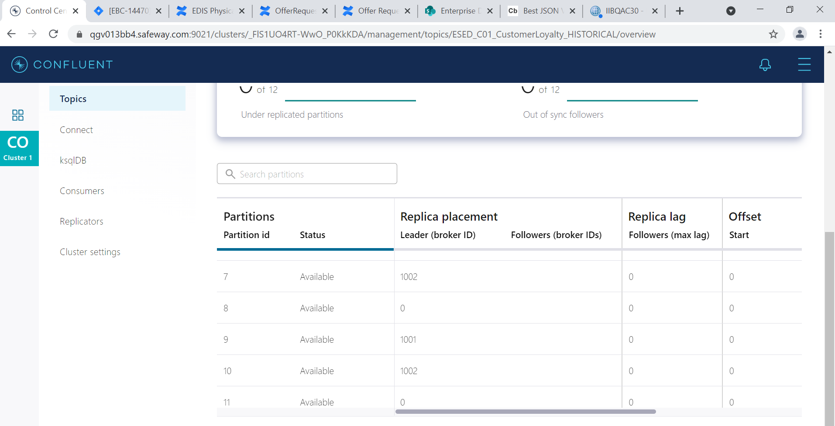

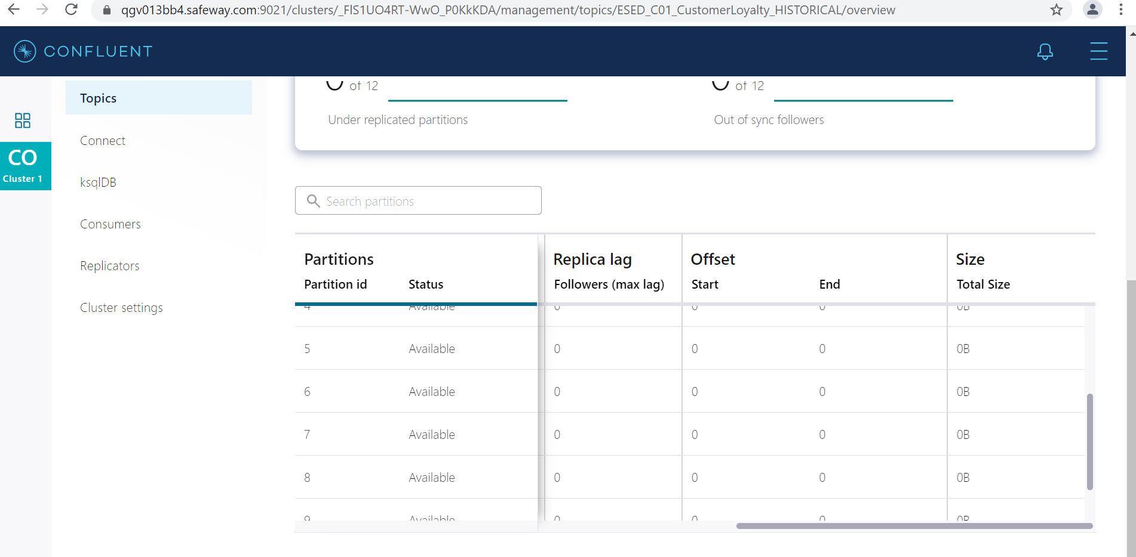

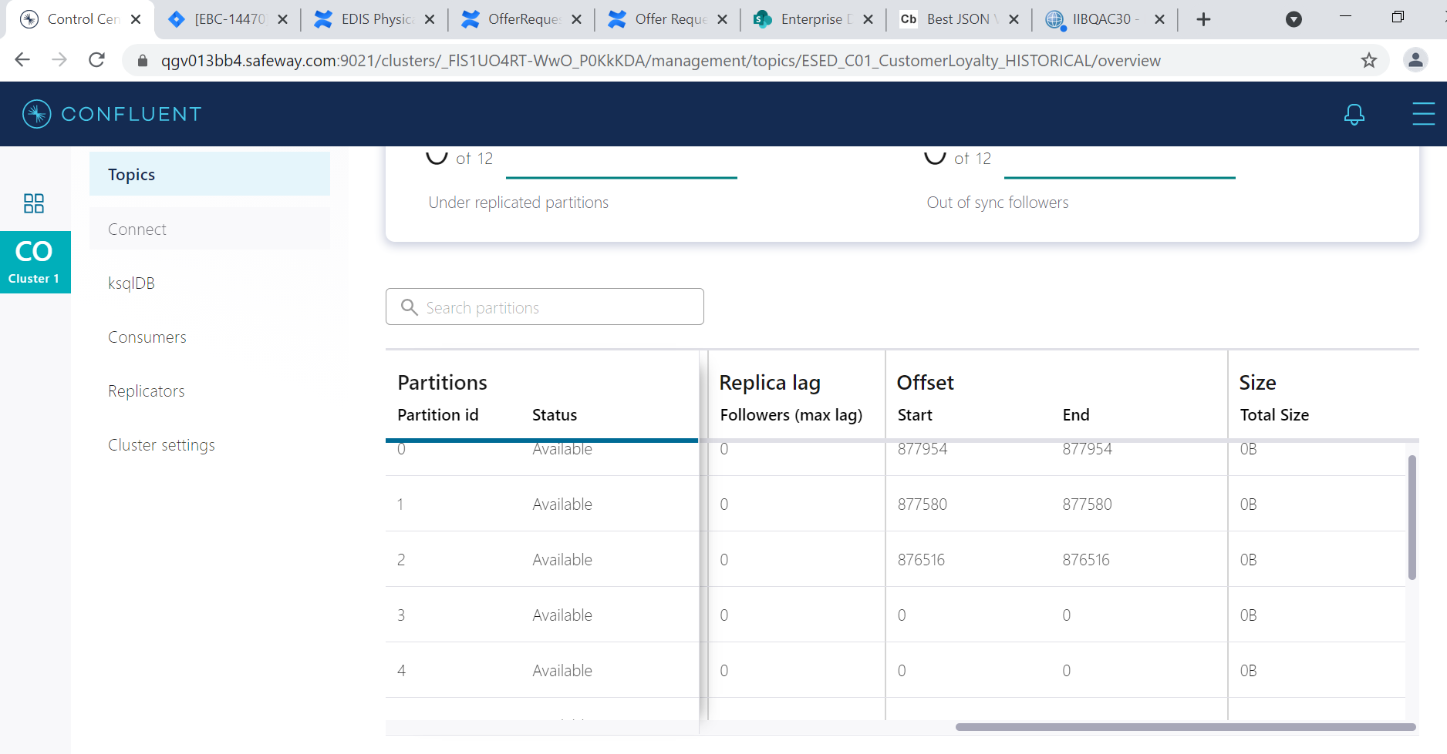

Today 25th May at 2:18 pm count of message is – 1,106,410

Existing old message on topic- 1,593,083

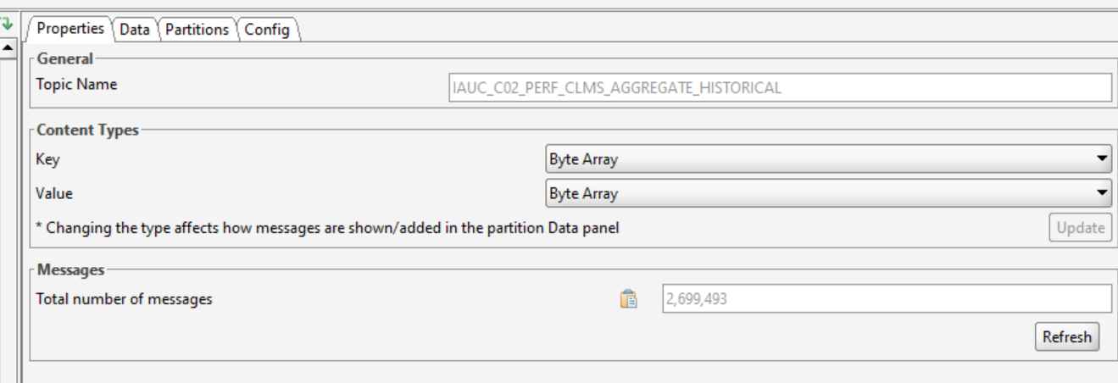

Started production of messages on topic at 25th May 2:18pm

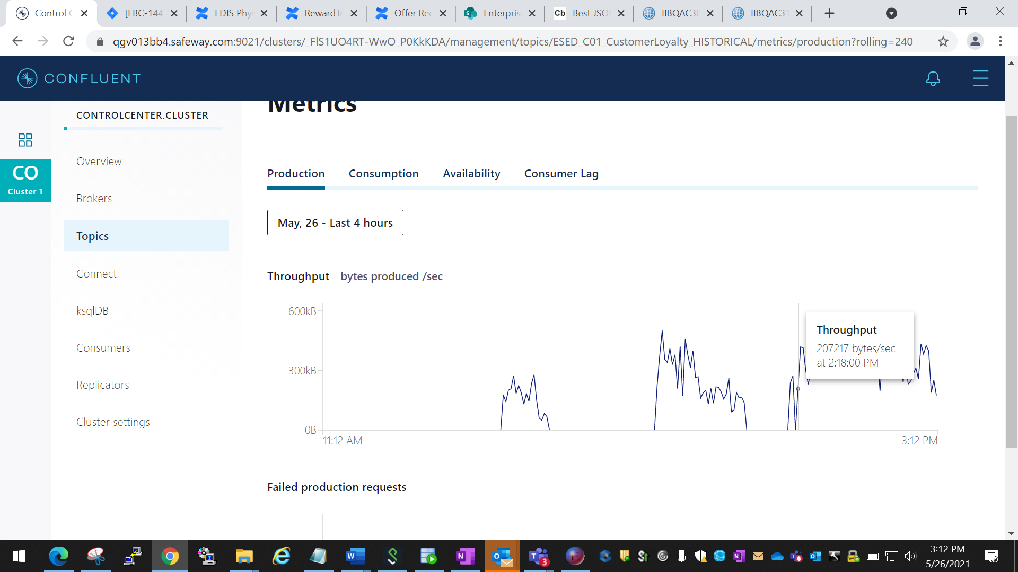

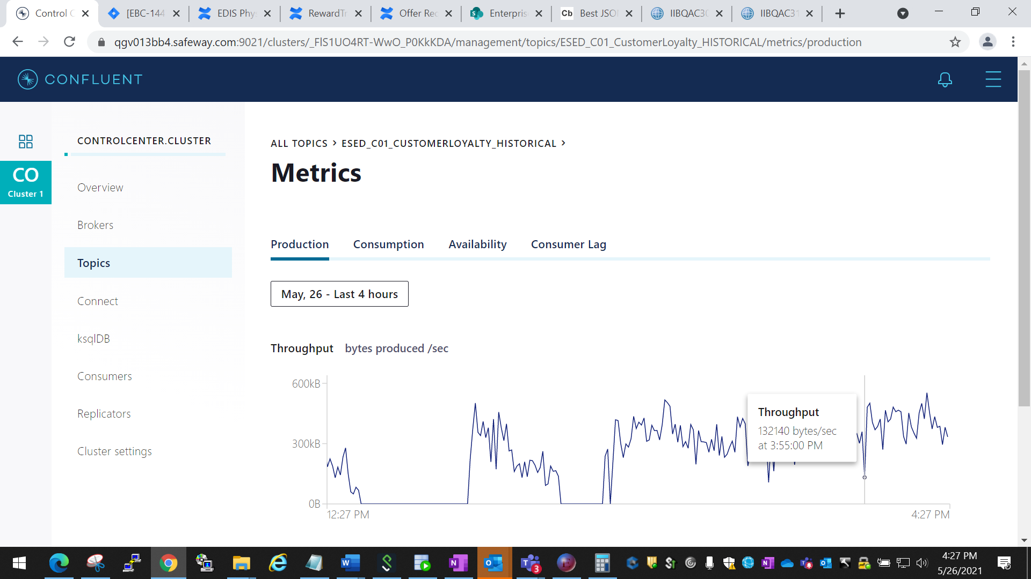

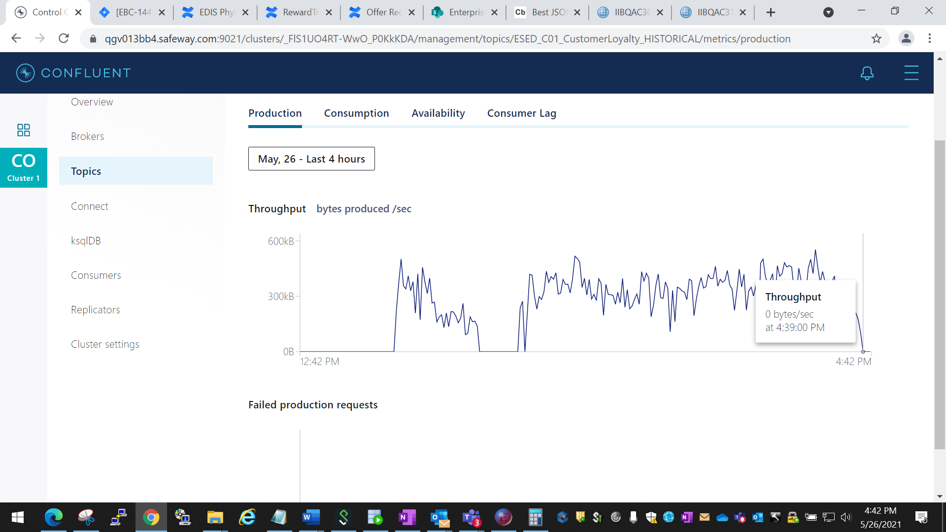

Existing message before consumption- 277,061

Additional Message consume-1,106,410

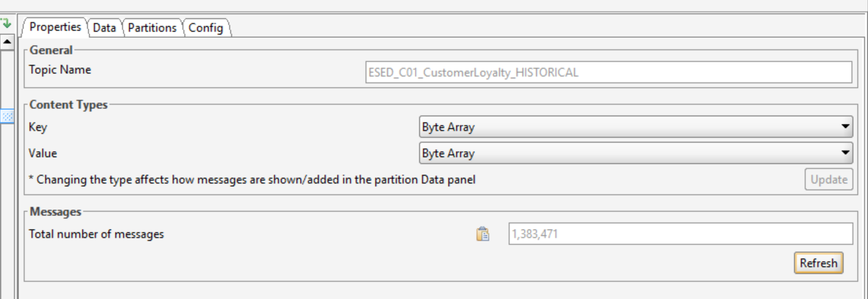

Total Time taken = 2:32 to Consume 1,106,410

**Round -3 After changing config on IIB side-**

following additional properties override-

com.abs.uca.customerloyalty.ESED_CustomerLoyaltyHistorical_UCA_IH_Publisher#KafkaConsumer.receiveBatchSize = 10

**Total message on source topic to consume-**

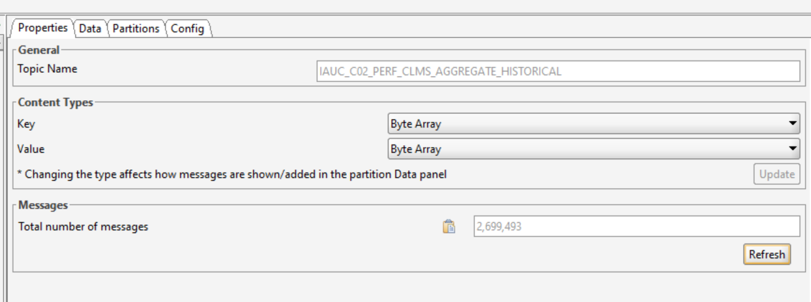

**Start Time for production-9:20 pm 5/27/2021**

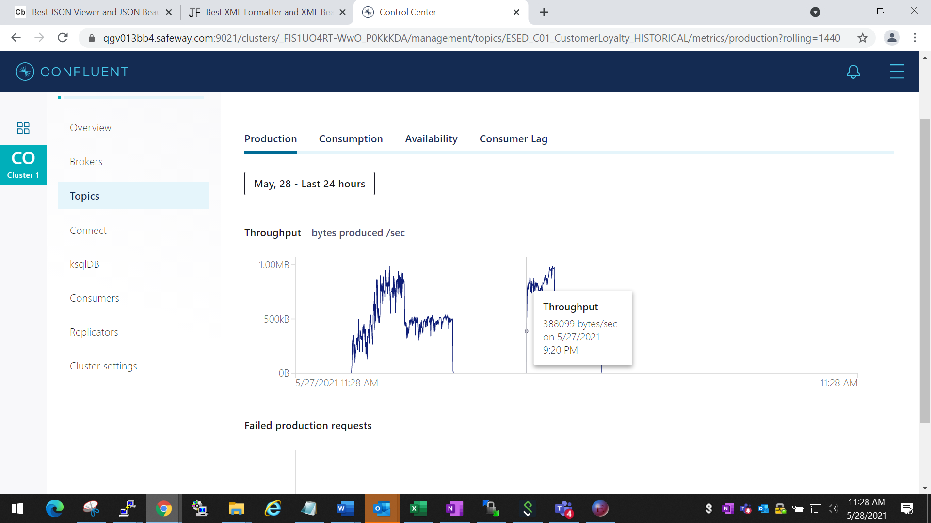

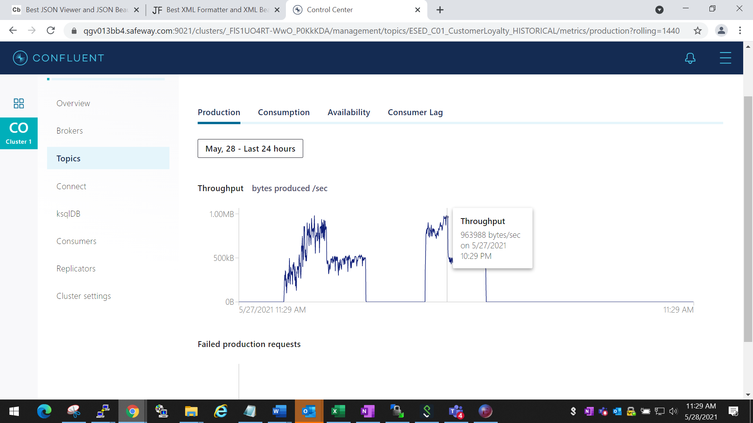

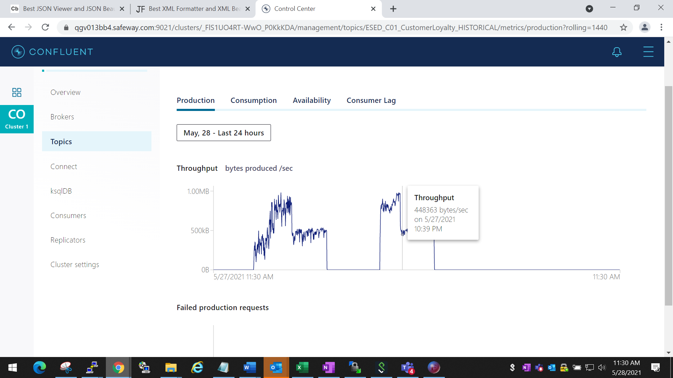

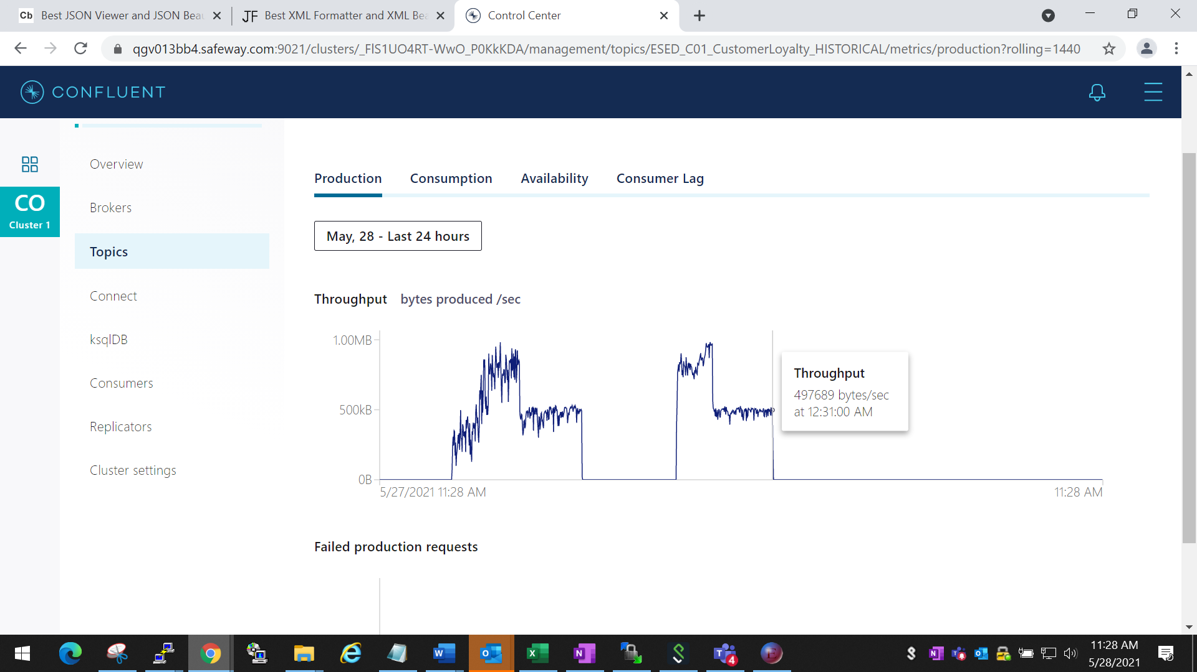

**Total time taken to consume=3 hrs 10 mins**